Guinea-Bissau

## Respect for rule of law (ROL) data

The data set shows the data on the respect of the rule of law for the country.

## # A tibble: 19 x 5  
## country iso3c date ruleOfLaw ruleOfLawCategory4   
## <chr> <chr> <dbl> <dbl> <chr>   
## 1 Guinea-Bissau GNB 1996 -1.67 ROL highly disrespected  
## 2 Guinea-Bissau GNB 1998 -1.80 ROL highly disrespected  
## 3 Guinea-Bissau GNB 2000 -1.32 ROL highly disrespected  
## 4 Guinea-Bissau GNB 2002 -1.17 ROL highly disrespected  
## 5 Guinea-Bissau GNB 2003 -1.14 ROL highly disrespected  
## 6 Guinea-Bissau GNB 2004 -1.17 ROL highly disrespected  
## 7 Guinea-Bissau GNB 2005 -1.25 ROL highly disrespected  
## 8 Guinea-Bissau GNB 2006 -1.25 ROL highly disrespected  
## 9 Guinea-Bissau GNB 2007 -1.31 ROL highly disrespected  
## 10 Guinea-Bissau GNB 2008 -1.39 ROL highly disrespected  
## 11 Guinea-Bissau GNB 2009 -1.34 ROL highly disrespected  
## 12 Guinea-Bissau GNB 2010 -1.33 ROL highly disrespected  
## 13 Guinea-Bissau GNB 2011 -1.31 ROL highly disrespected  
## 14 Guinea-Bissau GNB 2012 -1.52 ROL highly disrespected  
## 15 Guinea-Bissau GNB 2013 -1.59 ROL highly disrespected  
## 16 Guinea-Bissau GNB 2014 -1.33 ROL highly disrespected  
## 17 Guinea-Bissau GNB 2015 -1.28 ROL highly disrespected  
## 18 Guinea-Bissau GNB 2016 -1.49 ROL highly disrespected  
## 19 Guinea-Bissau GNB 2017 -1.44 ROL highly disrespected

## Respect for rule of law (ROL) trend

The plot shows the trend of the respect for the rule of law for the country.

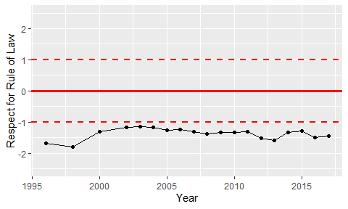

Trend of the Respect for the Rule of Law